INVENTION DISCLOSURE FORM FOR PATENTS

Applicant Name-Marwadi University

- Particulars of Inventors

Mr./Ms/Dr. | Name (Full) | Department | Designation | Mobile No. | Email | Postal Address
Mr | Rupesh kumar | Computer Engineering | Student | 9263519048 | Rupeshkumar.119197@marwadiuniversity.ac.in
Mr | Darshan thakar | Computer Engineering | Student | 8200136745 | Darshan.thakar@marwadiuniversity.ac.in
Dr. | Sushil kumar singh | Computer Engineering | Professor |  | sushilkumar.singh@marwadieducation.edu.in

- Provide title of the invention:
Blockchain-enabled Intelligent Scheme for BankSEC: Secure Smart Banking Environment

- In 100 words or less, please provide an abstract or summary of the invention:
The rapid evolution of digital banking presents significant challenges related to security, trust, and transparency in conventional smart banking systems, which often depend on centralized infrastructure and are consequently susceptible to fraud, identity theft, and data breaches. To address above challenges, we propose an Intelligent scheme for secure Smart Banking Environment based on blockchain, named BankSEC, which aims to eliminate single points of failure and enhance trust in digital transactions. The proposed system stores all financial activities on a decentralized, tamper-resistant ledger, ensuring integrity, transparency, and auditability. Biometric authentication such as fingerprint recognition is used instead of passwords to ensure strong and reliable identity validation. A Decentralized Identity (DID) mechanism further enables users to control their verified identity and minimize repeated KYC checks. Artificial intelligence is integrated to analyze transaction patterns in real time and detect suspicious behavior, thereby preventing fraud before it occurs. Smart contracts automate secure payments, P2P transfers, and loan processes, ensuring accuracy, efficiency, and transparency without third-party intervention. By

combining blockchain, biometrics, and AI under the BankSEC model, the proposed system establishes a secure, trusted, and user-centric Smart Banking Environment capable of addressing modern digital banking challenges.

4. Detail Description of the Invention

a. Problem the Invention is Solving
Traditional digital banking systems rely on centralized servers, making them vulnerable to hacking, data breaches, and fraud. Password-based authentication is weak and prone to phishing and identity theft. Repeated KYC processes increase inconvenience for users. Existing systems lack transparency and real-time fraud detection. These issues reduce user trust and increase financial losses. The proposed BankSEC system solves these problems by using blockchain, biometric authentication, artificial intelligence, and decentralized identity to provide a secure, transparent, and intelligent banking environment.

b. General Utility / Application of the Invention
The invention can be used in online banking, mobile banking, digital wallets, peer-to-peer payment systems, loan processing platforms, and fintech applications. It is useful for banks, financial institutions, government agencies, and digital service providers. The system ensures secure authentication, transparent transactions, and fraud prevention. It can also be applied in cryptocurrency platforms and digital identity management systems. Overall, the invention improves security, trust, and efficiency in modern digital financial services.

c. Advantages of the Invention
The BankSEC system provides high security using blockchain and biometrics. It removes dependency on passwords and centralized servers. AI enables real-time fraud detection. Smart contracts automate transactions and reduce manual work. Decentralized identity reduces repeated KYC processes. Transparency increases user trust. The system lowers operational costs and improves processing speed. It is reliable, scalable, and user-friendly. These advantages increase the efficiency, accuracy, and effectiveness of digital banking operations.

d. Best Way of Using the Invention and Possible Variants
The best way to use the invention is through wallet-based login, biometric verification, AI-based analysis, and smart contract validation before executing transactions. Users should perform all banking activities through the secured platform. Possible variants include mobile app implementation, integration with other blockchains, use of advanced biometrics like iris scan, cloud-based AI processing, and multi-currency support. These variants allow the system to adapt to different environments and user needs.

e. Working of the Invention
The user connects a digital wallet and completes biometric verification. The system generates and verifies decentralized identity. When a transaction is initiated, the AI module analyzes risk. Smart contracts validate transaction conditions. Valid transactions are stored on the blockchain. The user receives confirmation. This process ensures security, transparency, and automation.
Flow:
User → Wallet → Biometric → AI Check → Smart Contract → Blockchain → Confirmation
Diagrams such as system architecture, flowchart, and transaction process can be included.

5. Have You Conducted Primary Patent Search?
Answer: Yes
A primary patent search was conducted using Google Patents, WIPO, and Indian Patent Office databases. Existing patents related to blockchain banking, biometric authentication, and AI fraud detection were reviewed. The search helped in identifying research gaps and ensuring originality. Relevant search results are attached separately with this application.

6. Existing State-of-the-Art and Prior Arts
Current systems include centralized online banking, blockchain payment platforms, biometric authentication systems, and AI-based fraud detection tools. Banks use multi-factor authentication and centralized monitoring. Some fintech companies use blockchain for payments. However, most solutions focus on individual technologies. Very few systems combine blockchain, biometrics, AI, and decentralized identity in a single framework. The proposed invention improves existing methods by providing an integrated intelligent security platform.

7. Existing Solutions and Their Disadvantages
Existing Solutions:
- Password and OTP-based systems
- Multi-Factor Authentication (MFA)
- Blockchain payment systems
- Standalone biometric systems
- AI fraud monitoring tools

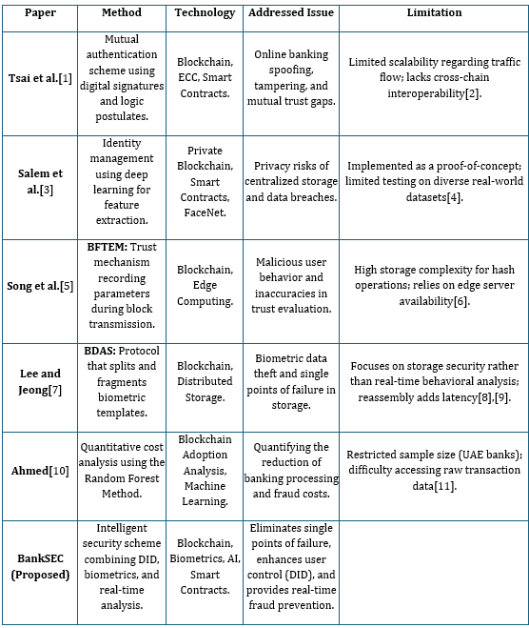

  - Drawings/Flowchart/Table

